CITI Training
CITI training stands for Collaborative Institutional Training Initiative or CITI. It is a college level ethics training that all researchers affiliated with a university or Institution must complete before beginning any research. It teaches why we must have training so that studies like Tuskegee, Willowbrook, or Nazi experiments never occur again. Everyone must complete the training during their freshmen year. This training is good for four years. Due October 17, 2025.

- Click on https://www.citiprogram.org/
- Click on Register.
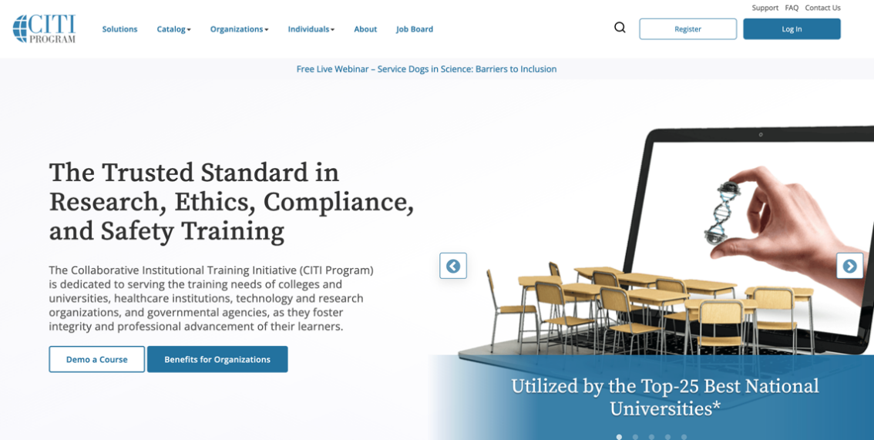

- Click on Select your organization affiliation
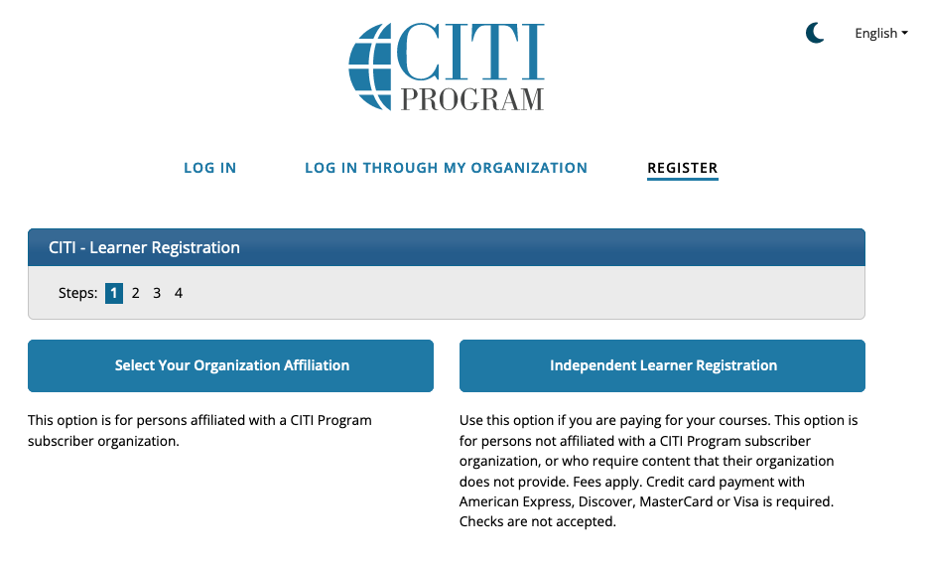

- Type in West Virginia University. Click I AGREE to the terms …
Click on I affirm that I am …
Then Click Create a CITI Program account
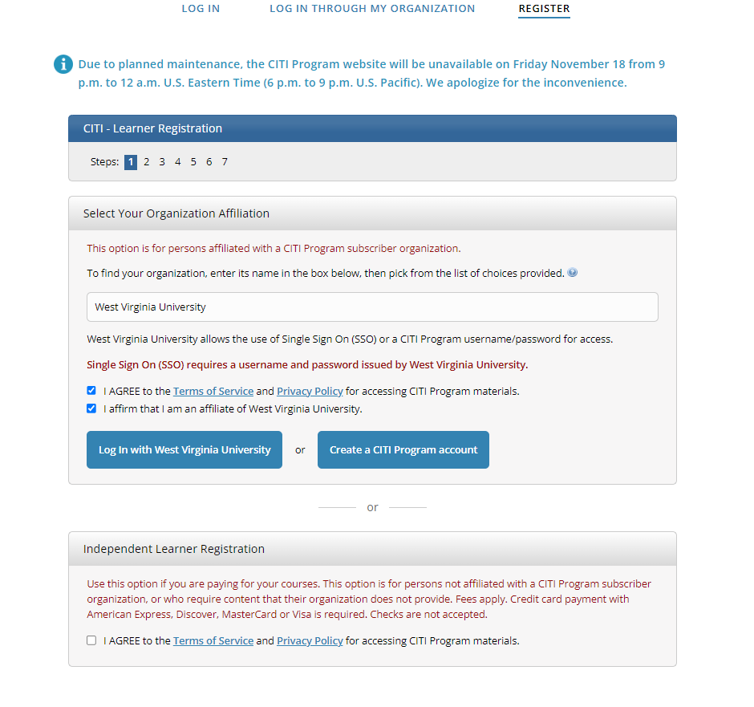

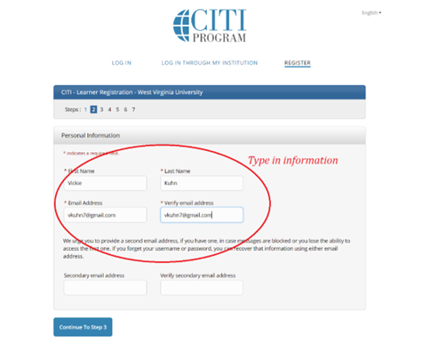
- Type in your information in the red circle, then click on Continue to Step 3.

5. Fill in all the information in the red circle. Click on Continue to Step 4.
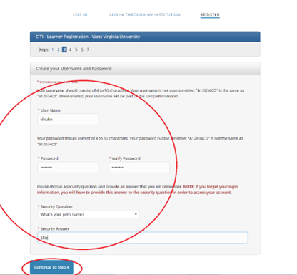

6. Skip down to Country of Residence and enter United States. On the next question check No and Click on Continue to Step 5.
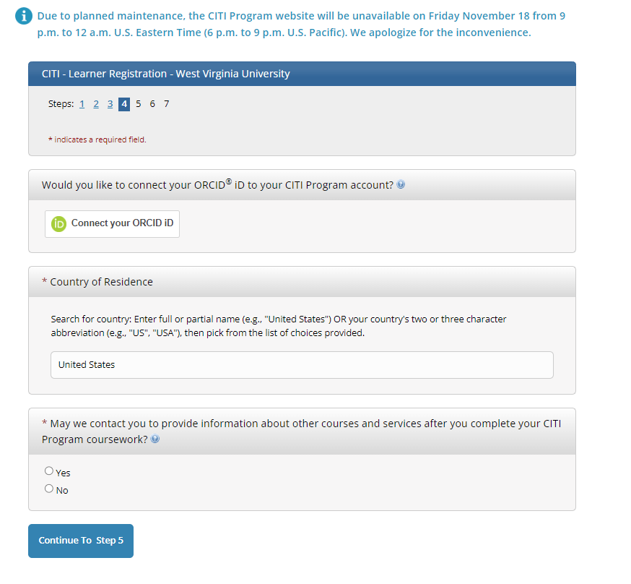

7. Click No to the first question, then click Continue to Step 6.
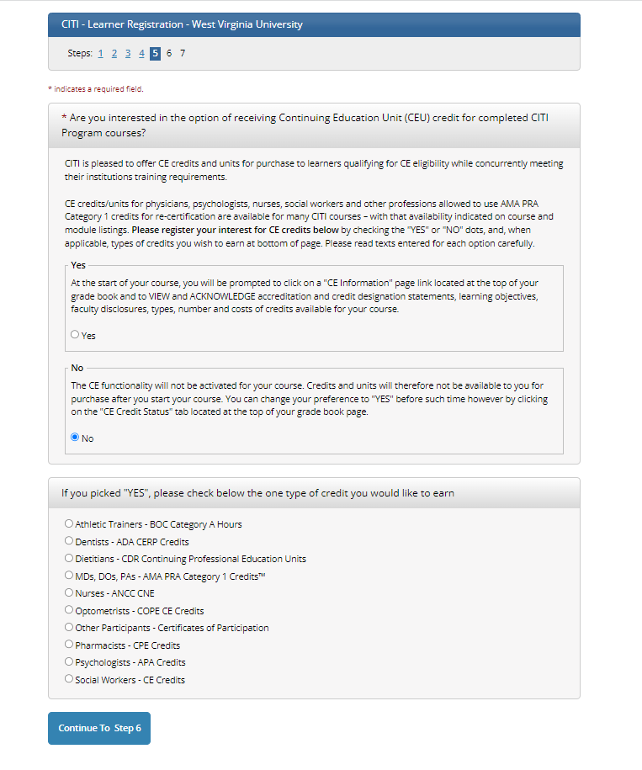

8. Fill in the boxes with the red *
- Language Preference - English
- Email - This can be a student email or personal email
- Department: HSTA
- Role: Student Researcher Undergraduate

9. Click To Final step
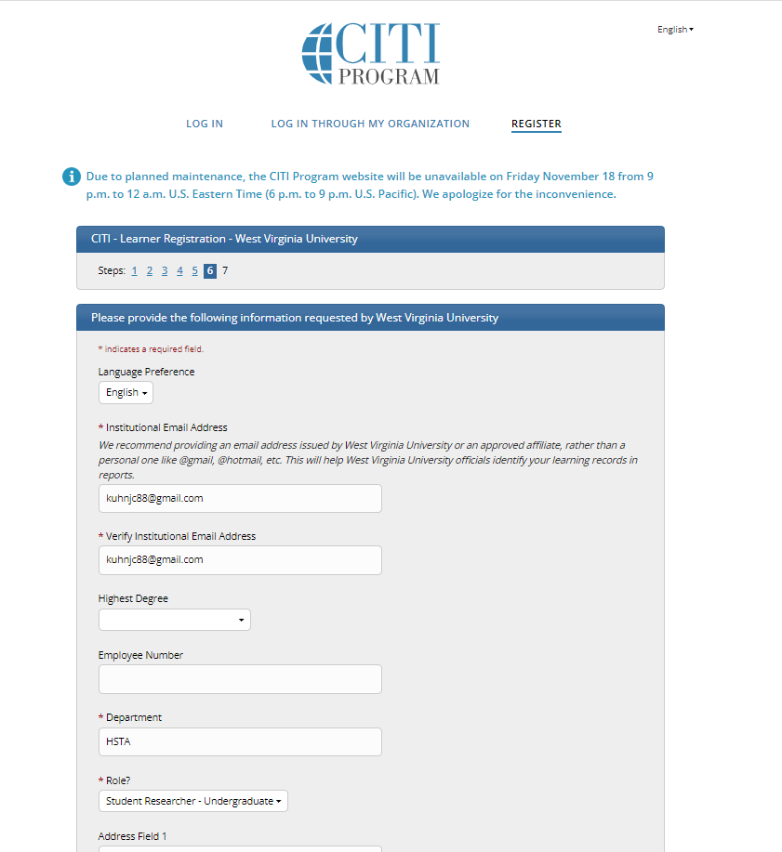

10. There will be a list of questions.
Click on the following course: Abbreviated Social/Behavioral Research Training (Human Subject Research).
11. Scroll to the very bottom and click Submit.
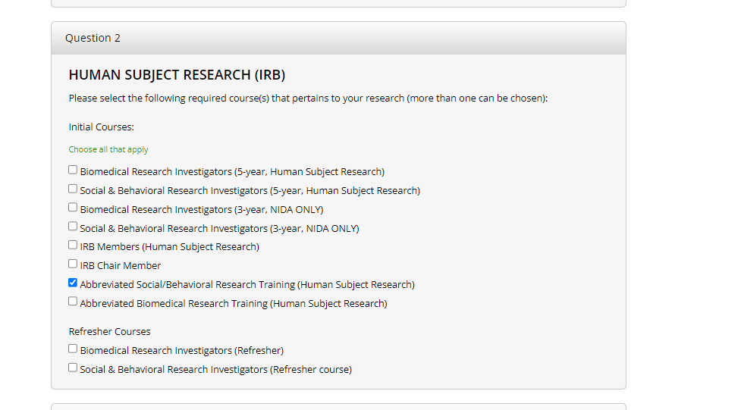

12. Click on Finalize Registration

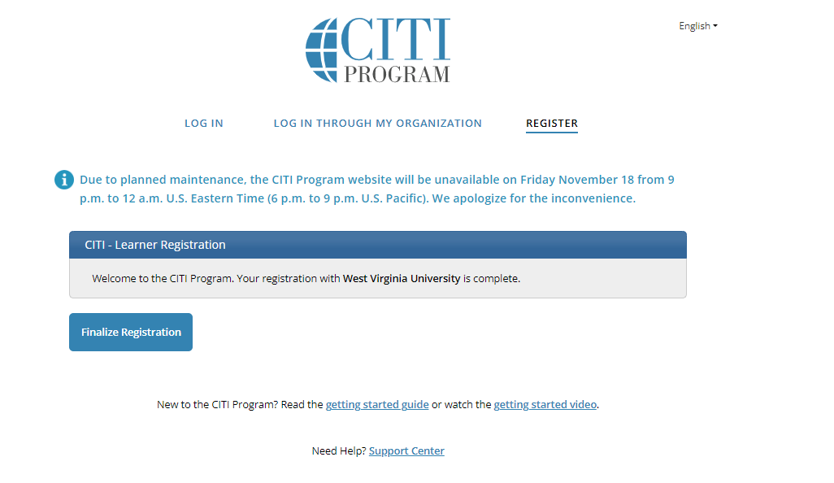

13. Click the icon View Courses

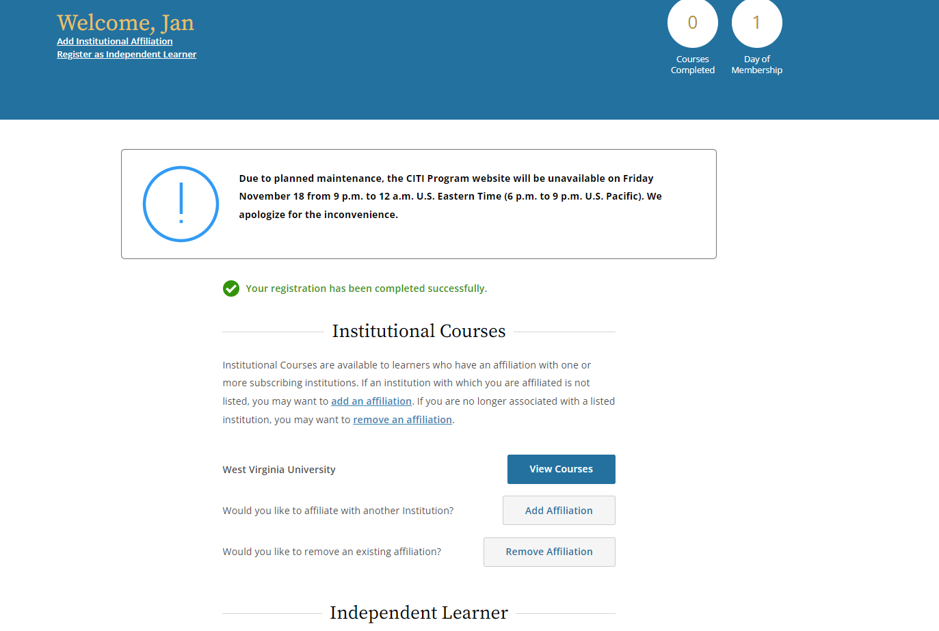

14. Click Start now.

You will read through the material and take quizzes. Not all sections will have a quiz. You need to score at least 80% in each section, and you can take the quizzes as many times as you need.

Use the rest of the meeting to complete your training. You can work together to complete the training.

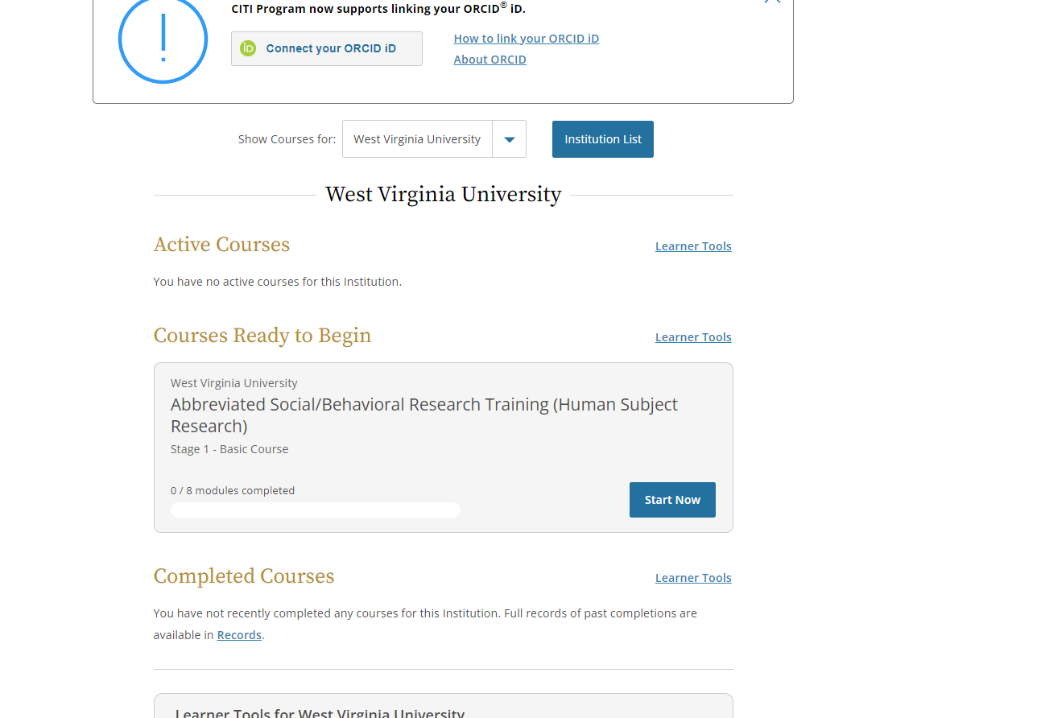

15. When you are done, you need to email your FSC a copy of your certificate. Due Date is October 17, 2025.

