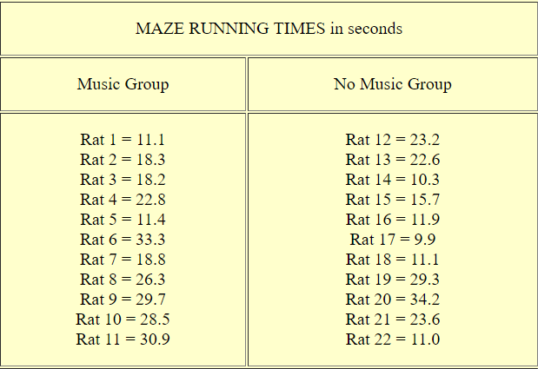
Data Set Example 4 with one Qualitative and Quantitative Variable

