HSTA TEAMS
Student Project Information



Table of Contents
STEM+M HSTA Project 3
Outline of Project 4
Final Presentation Notes 6
STEM+M Activities 11
STEM+M Survey 13
Templates for School Visits 17

STEM+M HSTA Project

Now that we have a little mentoring training, we will move onto preparing our HSTA project.
This project is a HSTA project you can carry out during the school year. The STEM+M project is composed of four educational activities where you will measure pre and post STEM+M interest among your middle school peers.
During your club meetings in the fall, you will prepare PowerPoint slides for Title, Observation, Background Information, Research Questions, Variables, Hypothesis, Procedures, and References. You will work with your HSTA teacher, HSTA college mentors, and HSTA partners.
You will submit your slides to your CRA for approval.
During approval, you will work with your HSTA teacher/staff and talk with a middle school to discuss plans to carry out your HSTA project.
Once approved, you will work with your HSTA teacher, HSTA partners, and Field Site to gather supplies. You will deliver your pre-survey, four hands-on activities, and post-survey to middle school peers over the course of 4 to 6 weeks.
Finally, you will analyze data and present your HSTA project at a symposium.

Outline of Project
*Proposal Presentation to be approved by CRA before data collection can occur*

Title: Will STEM+M hands-on activities increase STEM+M interest among middle school peers?
Observation: The workforce for STEM+M is growing. Cross age peer mentoring can help increase STEM+M interest among younger students.
Background Information: Examples for topics to research. Remember you need two facts per topic which must be cited in APA format.
- What is STEM+M?
- STEM+M Workforce in WV
- Cross-age peer mentoring
- STEM+M Interest
Research Question: Will STEM+M hands-on activities increase STEM+M interest among middle school peers?
Variables:
- Independent Variable (Categorical Variable)
  - Pre and Post STEM+M hands-on activities
- Dependent Variable (Numeric Variable)
  - STEM+M Interest Score
- Constants (items that do not change during your study)
  - WV Middle School Students
  - STEM+M Activities
  - Pre and Post Survey
- Control (the group of people that did not get the activities)
  - If you use a control group, give the activities to this group after the post survey.

Hypothesis:
  - If middle school students participate in STEM+M hands activities with HSTA students, then there will be a difference among pre and post STEM+M interest scores.
  - This is my/our hypothesis because, [……..].
  - Null Hypothesis: If middle school students participate in STEM+M hands on activities with HSTA students, then there will not be a difference between pre and post STEM+M interest scores.
Procedures: (Give details – the list below is an outline for you to use.)
- Completed ethics and lab safety training.
- Attended WVU Junior TEAMS Summer Camp
  - (Give details about summer camp).
- Completed slides Title – Procedures, Reference Slide.
- Received approval from HSTA Teacher and CRA.
- Prepared four hands on activities to give to at least 30 middle school peers.
  - (Talk about each activity, what materials are needed, and what middle school students will learn).
- Talked with a middle school teacher about attending their class.
- Talked with HSTA teacher and Field Site about materials needed.
- Created PowerPoints for each school visit.
- Set up dates and times for visits.
- Sent informational cover letter home to parents.
  - (put a copy of this letter in your presentation; see page XXX)
- Conducted school visits, pre/post Surveys via REDCap, and activities.
  - (more information about surveys on page XX; put into presentation)
- Requested data from CRA.
- Performed descriptive and inferential statistics. (give details)
- Drew conclusion.
Reference Slide: Remember you need four references. Make sure to cite in APA format.

Final Presentation Notes

Data Slides for Descriptive Statistics
Total number of participants: ______
What grade did you survey? ______
----------------------------------------------------------------------------------------------------
Find the percentage for each gender.
Gender | Total Number | Percentage
Female
Male
Total

Put this data in a pie chart.

Continued Data Slides for Descriptive Statistics
The Independent Variable is Pre and Post Intervention. This variable is categorical. No descriptive data is needed.
----------------------------------------------------------------------------------------------------
The Dependent Variable is STEM+M Interest Score
- Responses are numeric. The range is ___________.

Complete the chart below and create a bar graph.
Average STEM+M Score
Pre-Intervention
Post Intervention

Example of a bar graph:

Data Slides for Inferential Statistics
- t-test is an inferential statistic to test if there is a significant difference between the average STEM+M scores pre and post-activities.
- Set up a t-test in Excel.
Student Code | Pre-Intervention | Post-Intervention
 | STEM+M Score | STEM+M Score
 | STEM+M Score | STEM+M Score
 | STEM+M Score | STEM+M Score
 | STEM+M Score | STEM+M Score
- Follow the t-test directions.

  - t-test = If you want to see if there is a difference between two groups, you can test for a significant difference using a t-test.
  - By doing a t-test, you get a p value:
    - If you get a p value of less than .05 or 5%, then there is a significant difference. This means that you can safely say at least 95% of the time you see a difference.
    - If you get a p value of more than .05 or 5%, then there is no significant difference. This means the data is similar more than 5% of the time.

Directions for t-test (also check out the HSTA lesson on t-test for helpful videos)
1. Open Excel
2. Create a chart like the one to the left: Label IV and record DVs
3. Fill in the columns with results
4. Click on a blank cell where you want to have the t-test appear
5. Click on 'Formulas', 'More Functions,' 'Statistical,' and then 'TTest'
6. For 'Array 1' highlight the first column of the numbers
7. For 'Array 2' highlight the second column of the numbers
8. For 'Tails' type in 2 (You will almost always be doing a two-tailed test, meaning your data goes in two directions - higher or lower, as opposed to one direction)
9. For 'Type'
  - Choose "1" (paired t-test) if you are comparing a pre and post measurement taken on the same group
  - Choose "2" if you are comparing one measurement taken on two different groups
10. Click OK and the t-test result will appear.
11. You will get a p value.
  - If it is less than 0.05 then yes, there is a difference between the data in column 1 and 2
  - If it is more than 0.05 then no, there is not a difference between the data in column 1 and 2

Conclusion Slide
- Include a brief summary of the project.
- Interpret the data and state if the data supported/rejected the hypothesis.
- State if the conclusion answered the research question.
- Discuss limitations of the project.
- Explain how you would implement change in and/or bring awareness to your community.

STEM+M Activities
- Activities should be based on your summer camp experience.
- The goal is to increase STEM+M interest among middle school peers.
- You need four activities that will get middle school peers interested in STEM+M. Below are a few examples of activities related to a topic.
- Read through the ideas, then brainstorm with your group four activities you could carry out with your middle school peers.

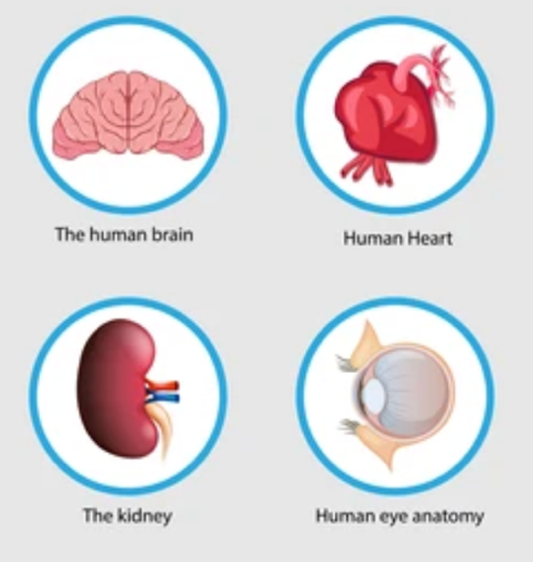
Summary: HSTA Students will introduce dissection and body systems by dissecting a sheep/cow heart, eye, kidney, and brain.
Activities for School Visits:
1. Heart Dissection. Purpose and Function of the heart.
2. Kidney Dissection. Purpose and Function of the kidney.
3. Eye Dissection. Purpose and Function of the eye. Expert/video to talk about careers related to body systems/anatomy.
- Brain Dissection. Purpose and Function of the brain.

If you want, you can change STEM+M to the career field you worked closely with during summer camp.
Title: Will STEM+M hands-on activities increase STEM+M interest among middle school peers?
Example – Nursing Group.
Title: Will nursing hands-on activities increase nursing interest among middle school peers?

Group Topic: _______________________________________________________
#1

#2

#3

#4

STEM+M Survey
- Before data is collected, you will work with your HSTA teacher and classroom teacher to send home information letters to parents. (See page 13)
- Before they complete the survey, you will read them the script. (See page 14)
- Everyone will use the same pre and post-surveys.
  - You will give middle school peers the REDCap links:
    - Pre: https://redcap.link/pre_stem2025 before the activities
    - Post: https://redcap.link/post_stem2025 after all the activities
    - Both surveys will start with a student code. Middle School Students will answer three questions:
        - Initial of your middle name
        - Birth Month
        - Birth Date
      - will ask about county and gender
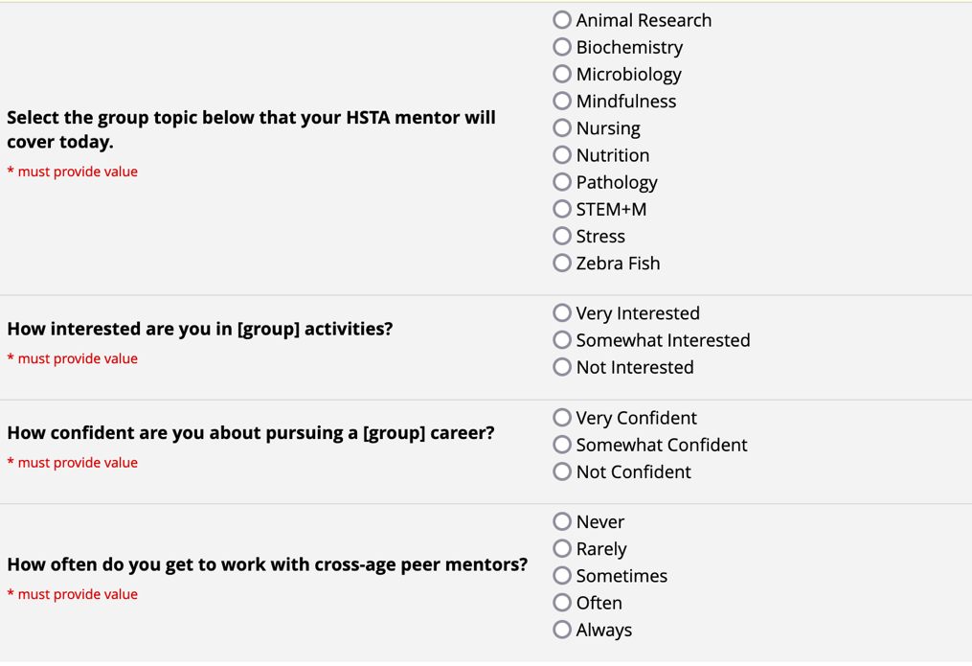
      - will ask the questions below. Make sure to tell the middle school students which group you want them to select. If your activities are general, have them select STEM+M. If your activities are related to another group, tell them which one to select.

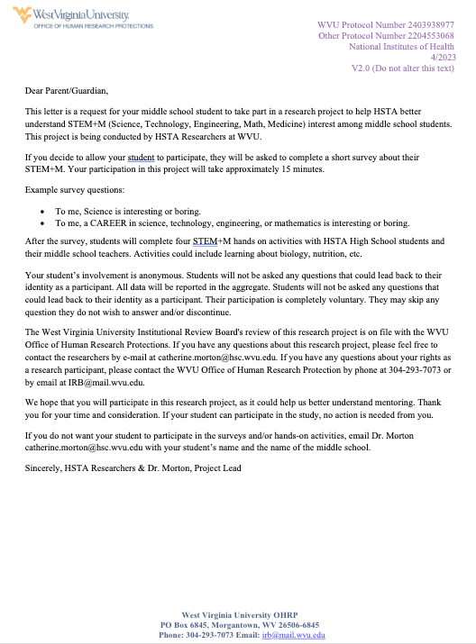
Script to read for pre survey:
Hi. My name is ______ and I am a HSTA student. I am excited to work through four STEM+M (science, technology, engineering, math and medicine) activities. Before I do this, I would like you to take a brief survey on your computer. This survey will ask you about how you feel about STEM+M. You do not have to take this survey if you don’t want to. You don’t have to answer all the questions and your name will not be used. Your answers will be kept protected and private. If you have questions, I can try and answer them for you. (Wait for a few minutes to see if any students have questions. If there are no questions and/or after you have answered questions, continue with the following script) If you are ready to take the survey, please raise your hand.
Thank you for taking the survey and now we will have our first STEM+M activity.
Script to read for post survey:
I hope you enjoyed the four STEM+M activities. It was a fun experience for me. I would like you to take a brief survey on your computer. This survey will ask you about how you feel about STEM subjects like math, science, and engineering. This survey will also ask you how much you liked the STEM+M activities. You do not have to take this survey if you don’t want to. You don’t have to answer all the questions and your name will not be used. Your answers will be kept protected and private. If you are ready to take the survey, please raise your hand.
Thank you for taking the survey and participating in the STEM+M activities.

Templates for School Visits
Work with your HSTA teacher and classroom teacher to set up dates and times. Make sure information letters were sent home. If anyone returned their letter, do not allow that student to take the survey.
- First School Visit (75 Minutes)
  - Quick Introductions: 2 minutes
  - Rules: 3 minutes
  - Pre-test for participants: 10 minutes
  - What is HSTA and a little bit about me/team: 5 minutes
  - Introduction of topic followed by first hands-on activity: 45 min
  - Clean Up/Wrap Up: 10 minutes
- Second School Visit (75 Minutes)
  - Quick Re-introduction: 2 minutes
  - Review Rules: 3 minutes
  - Introduction of topic followed by second hands-on activity: 45 min
  - Guest Speaker: 15 Minutes [Video or this can be a separate visit where the guest speaker comes in person.]
  - Clean Up/Wrap Up: 10 minutes
- Third School Visit (60 Minutes)
  - Quick Re-introduction: 2 minutes
  - Review Rules: 3 minutes
  - Introduction of topic followed by third hands-on activity: 45 min
  - Clean Up/Wrap Up: 10 minutes
- Fourth School Visit (75 Minutes)
  - Quick Re-introduction: 2 minutes
  - Review Rules: 3 minutes
  - Introduction of topic followed by fourth hands-on activity: 45 min
  - Clean Up: 10 minutes
  - Posttest for participants: 10 minutes
  - Wrap Up/Thank you: 5 minutes

