HSTA TEAMS

Student Mentor Training



Table of Contents

Pre-Test 2

Welcome 3

Introductions 4

Ice Breaker 6

What is a Mentor? 7

6 Cs of Mentoring 34

Post Survey 35

# Pre-Test

Before we move on, we will measure our pre-mentoring knowledge and skills. Scan the QR code on your phone, use a neighbor’s phone, and/or ask a HSTA Teacher for help. You will complete the survey questions. Once you complete your survey, hit submit.

~~

<https://redcap.link/pre_teams2025>

# Welcome

Welcome to Mentor Training! You are part of a National Institutes of Health (NIH) Science Education Partnership Award (SEPA) Project.

What is NIH?

* “The National Institutes of Health (NIH), a part of the U.S. Department of Health and Human Services, is the nation’s medical research agency — making important discoveries that improve health and save lives.” From <https://www.nih.gov/about-nih/who-we-are>

What is SEPA?

* “The SEPA program supports educational activities that encourage pre-college students (pre-kindergarten to grade 12) from diverse backgrounds, including those from groups underrepresented in the biomedical and behavioral sciences, to pursue further studies in science, technology, engineering, and mathematics (STEM).” From <https://www.nigms.nih.gov/capacity-building/division-for-research-capacity-building/science-education-partnership-awards-(sepa)>

What is the project goal?

* Our goal for this project is to increase STEM+M interest among middle school students to grow the STEM+M workforce. STEM+M represents Science, Technology, Engineering, Mathematics plus Medicine.

Today we will go over what a mentor is, how to build mentor skills, and prepare middle school STEM+M interest projects.

# Introductions

We will use the HSTA TEAMS (Teaching Educators and Adolescents Mentoring and Science) Model to learn about mentoring and to deliver STEM+M interest activities to middle school peers. This training will build your mentor skills and assist you in developing and executing your HSTA research project.

You will have a mentor team behind you. Your HSTA Teacher will be your lead mentor during the school year as you prepare, deliver, and complete your STEM+M research project. The HSTA undergraduate will be a peer mentor during summer camp and part of the school year. The HSTA Summer Camp Faculty will be your advisor mentor during summer camp as you brainstorm ideas for your four hands on activities for middle school peers. Finally, your HSTA CRA will be your research mentor that will assist you and the HSTA Teacher during the school year.

In addition to the mentor training at camp, you will also prepare STEM+M interest activities in your camp group. These four activities will be delivered to middle school peers and test if HSTA students can impact STEM+M interest among middle school peers.

***HSTA TEAMS Model***

# Ice Breaker

During your middle school visits, you will do ice breakers with your middle school peers to get to know them. Complete Post-it Statues as a group then brainstorm four more ice breakers that could be used with middle school peers.

**Post-it Statues**: Split your group into teams of five or six. Give each team Post-it notes. In three minutes, they must cover one person in the group as completely as possible with Post-it notes. Count which group got the most. Be respectful to each other as you complete the task.

Now, see who can get them all off the fastest. Be respectful to each other as you complete the task.

**Brainstorm four ice breakers:**

Now as a group, brainstorm at least four fun and engaging ice breakers you would lead for middle school peers.

|  |  |
| --- | --- |
|  |  |
|  |  |

# What is a Mentor?

Now we are going to cover *what a mentor is*.

Sticky Note Activity

Take the blue sticky notes on your table and write down who has been a mentor to you. Each sticky note will have a different person on it. Place all the sticky notes on the large poster labeled Who has been a mentor to you?

Take the yellow sticky notes on your table and write down key words you think makes a good mentor. Each sticky note is a different key word. Place all the sticky notes on the large poster What makes a good mentor?

Take the green sticky notes on your table and write down what makes a poor mentor. Each sticky note is a different key word. Place all the sticky notes on the large poster labeled What makes a poor mentor?

Discuss each poster with sticky notes. What were the common themes?

|  |  |  |
| --- | --- | --- |
| Who has been a mentor to you? | What makes a good mentor? | What makes a poor mentor? |
|  |  |  |
|  |  |  |
|  |  |  |
|  |  |  |
|  |  |  |
|  |  |  |
|  |  |  |
|  |  |  |
|  |  |  |
|  |  |  |
|  |  |  |
|  |  |  |
|  |  |  |

***What is mentoring?***

“Mentoring takes place between young persons (i.e., mentees) and older or more experienced persons (i.e., mentors) who are acting in a non-professional helping capacity to provide support that benefits one or more areas of the mentee’s development.” (Dubois & Karcher, 2014)

***What is a mentor?***

A mentor is someone who supports, advises, and guides another. This person can be a family member, friend, coworker, teacher, older student, etc. A mentee is the person who is being mentored.

In HSTA you will have a team of mentors – HSTA Teacher Lead Mentor, College Peer Mentor, HSTA Faculty Advisor Mentor, and HSTA CRA Research Mentor. Your team will help you prepare your HSTA research project and deliver the project to your middle school peers.

You will also serve as a mentor. You will be a cross-age peer mentor. A cross-age peer mentor is an older youth (high school student) working with younger youth (middle school student) in a structured environment.

<https://laurenmkaufman.com/2021/01/30/mentorship-matters-the-6-cs-to-successful-mentor-mentee-relationships-series-2/>

**Mentor Training**

The following information is from the High School Teen Mentoring Handbook <https://files.eric.ed.gov/fulltext/ED506100.pdf>.

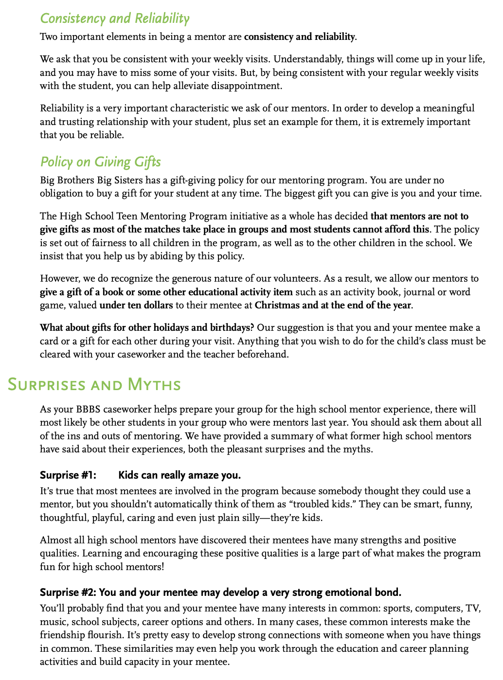

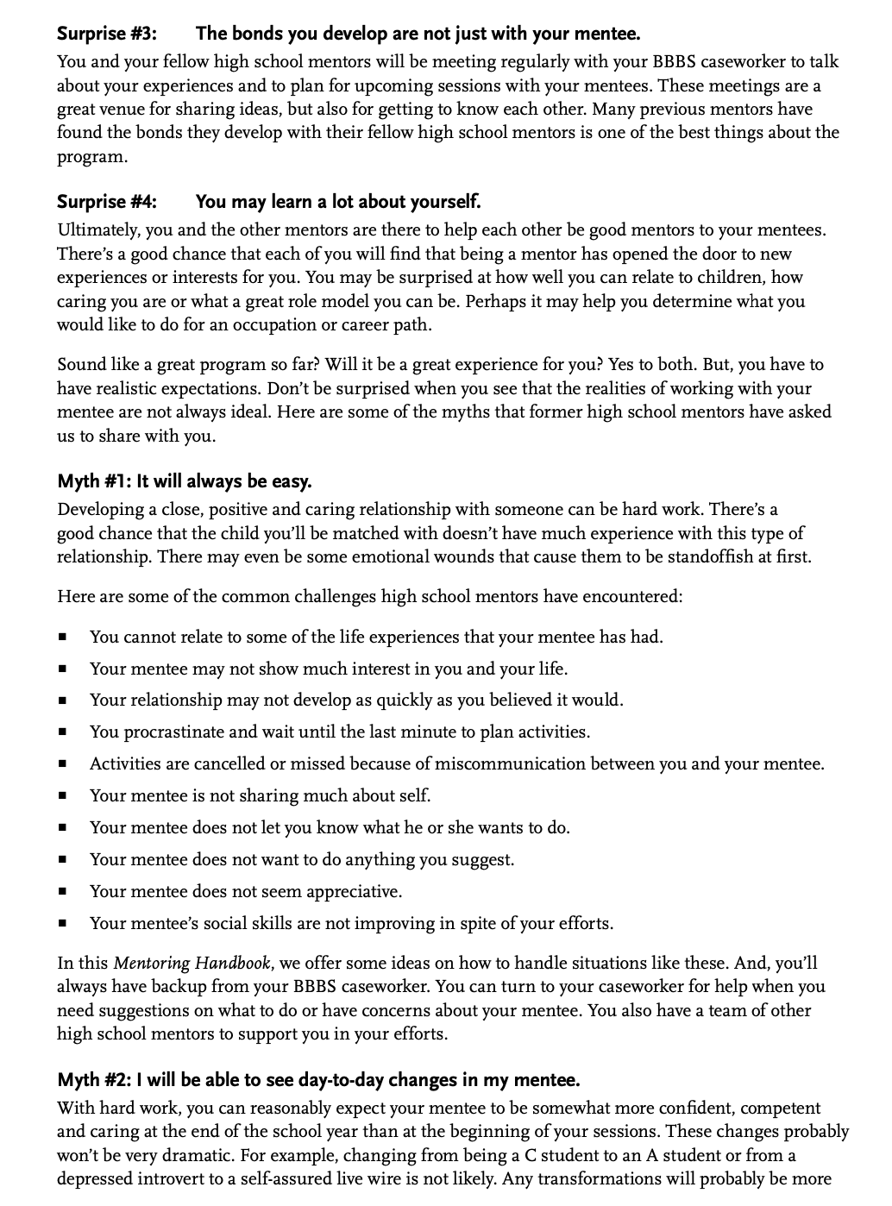

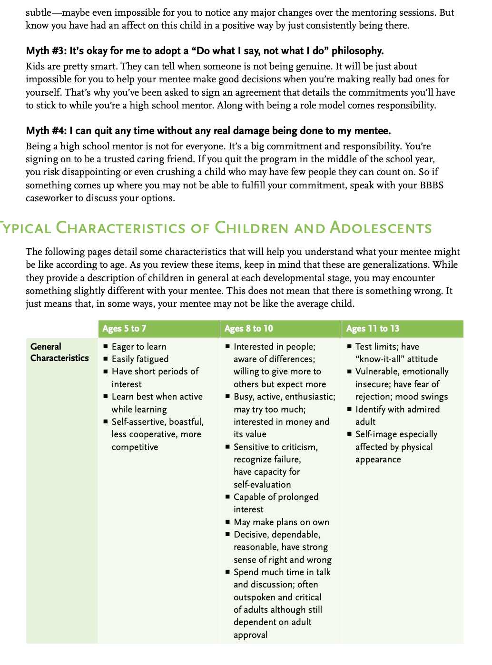

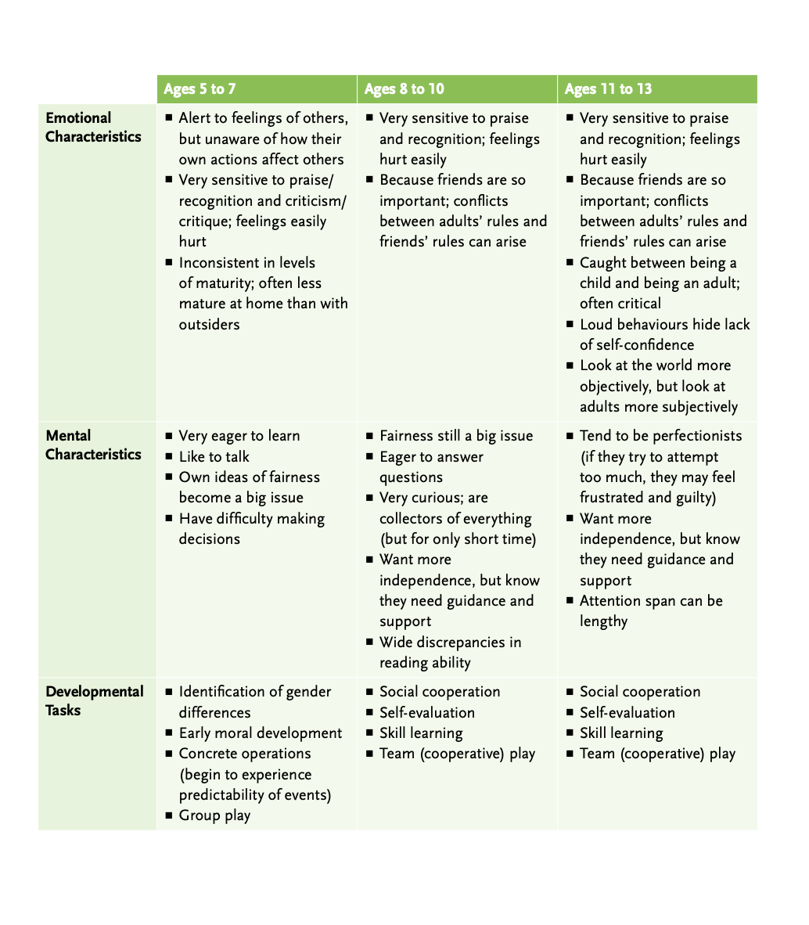

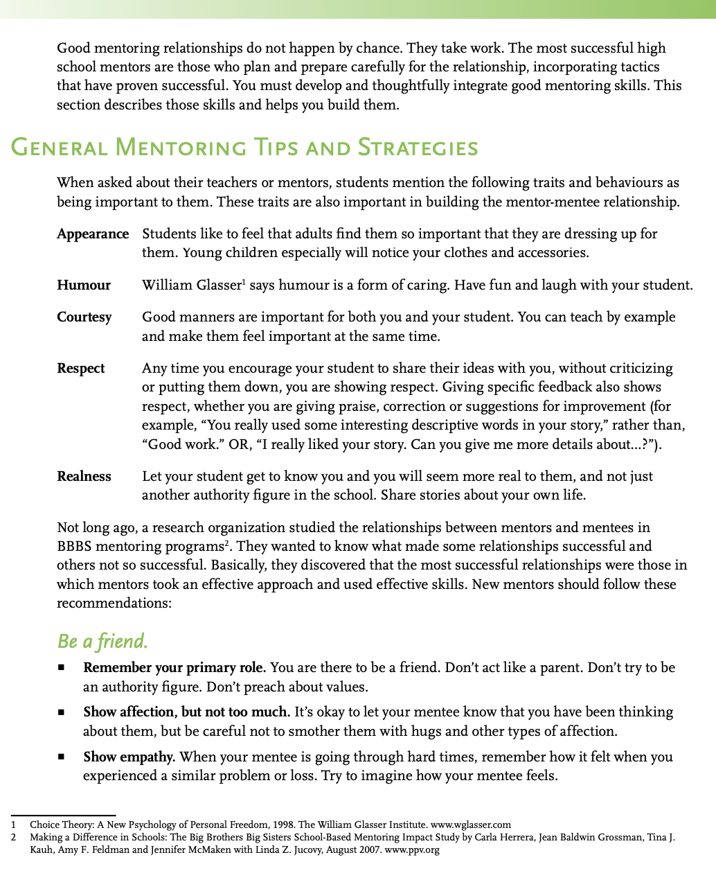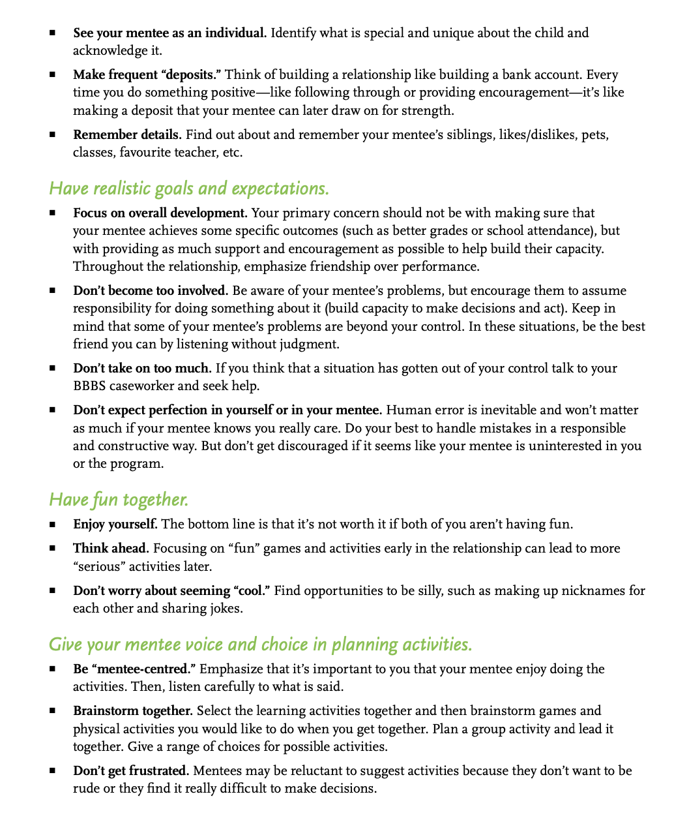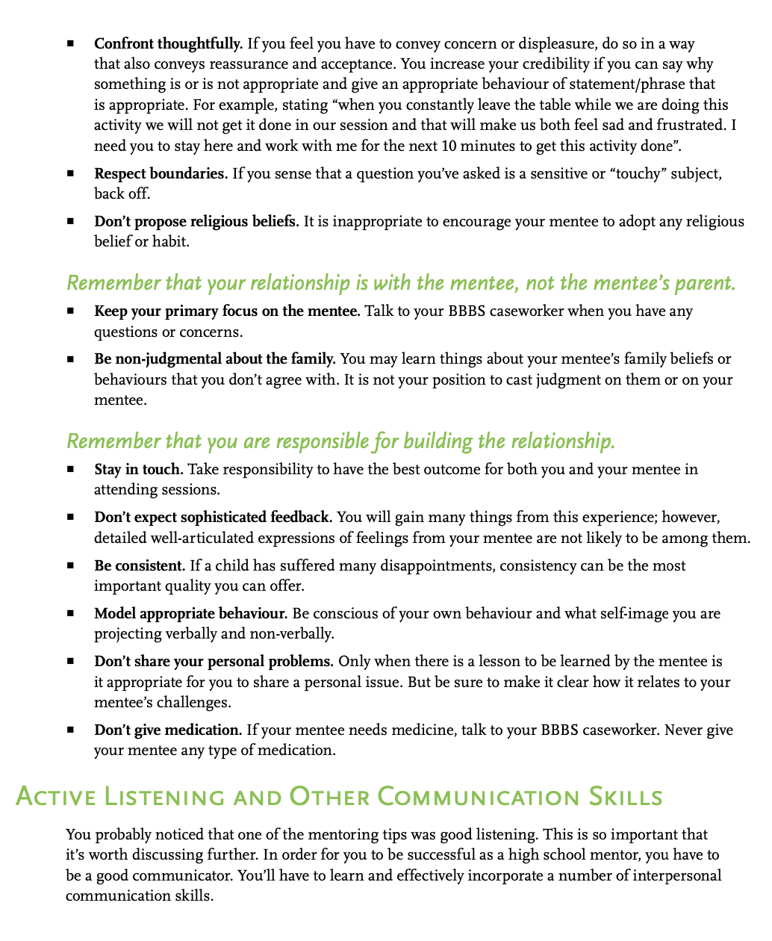

# 6 Cs of Mentoring

1. **Competence**: Positive view of one’s actions in specific areas including social, academic cognitive, and vocational.
2. **Confidence**: The internal sense of overall positive self-worth and self-efficacy, identity, and belief in the future.
3. **Connection**: Positive bond with people and institutions, peers, family, school, and community in which both parties contribute to the relationship.
4. **Character:** Respect for societal and cultural rules, possession of standards for correct behaviors, a sense of right and wrong (morality), spirituality, integrity
5. **Caring and Compassion**: A sense of sympathy and empathy for others
6. **Consistency**: Steady, dependable continuity or following through and being consistent and dependable, especially for others.

*Revised from Building Effective Peer Mentoring Programs in Schools (5 Cs of Youth Development)*

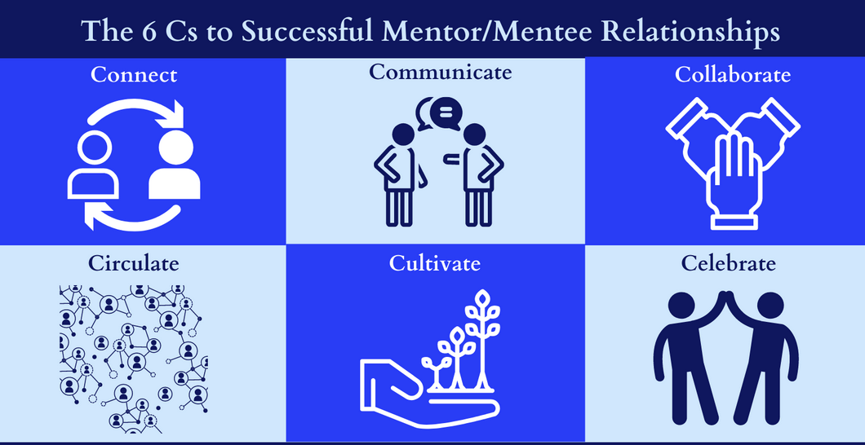

# Post Survey

Before we move on, we will measure our post-mentoring knowledge and skills. Scan the QR code on your phone, use a neighbor’s phone, and/or ask a HSTA Teacher for help. You will complete the survey questions. Once you complete your survey, hit submit. ​

​

<https://redcap.link/post_teams2025>

